Start Application:

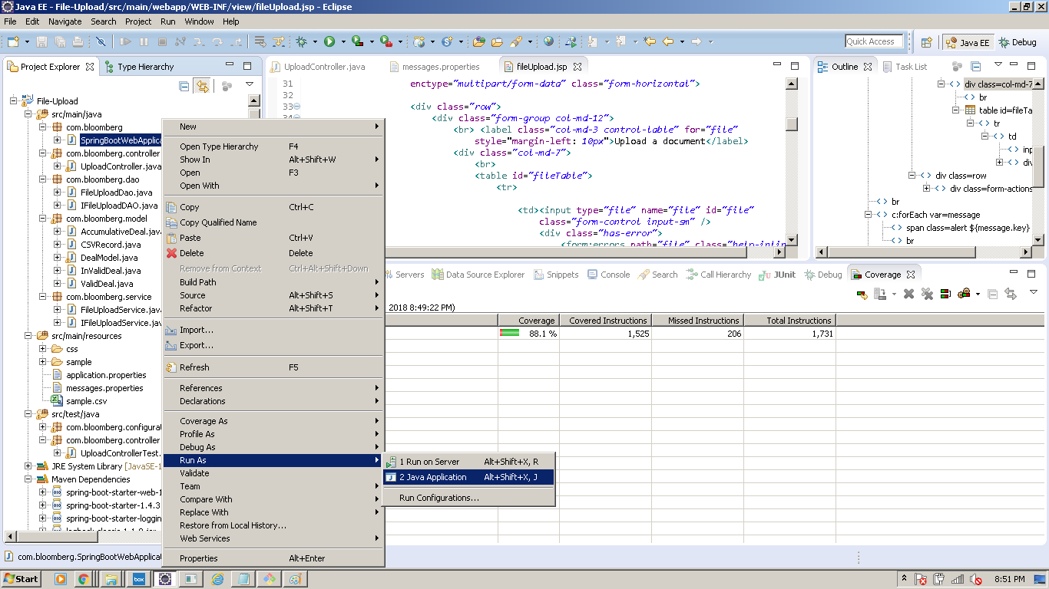

Right Click on SpringBootWebApplication.java > Run As > Java Application.

URL to access UI : localhost:8099

Upload file and Summary

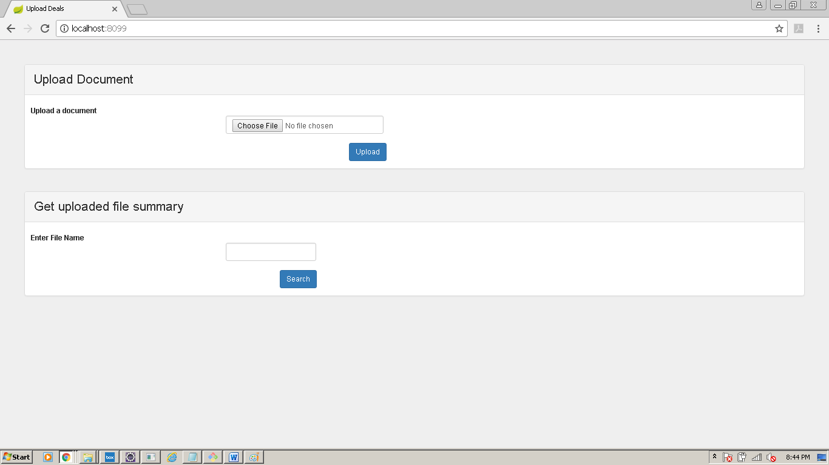

Checking Validation

1. No File Uploaded

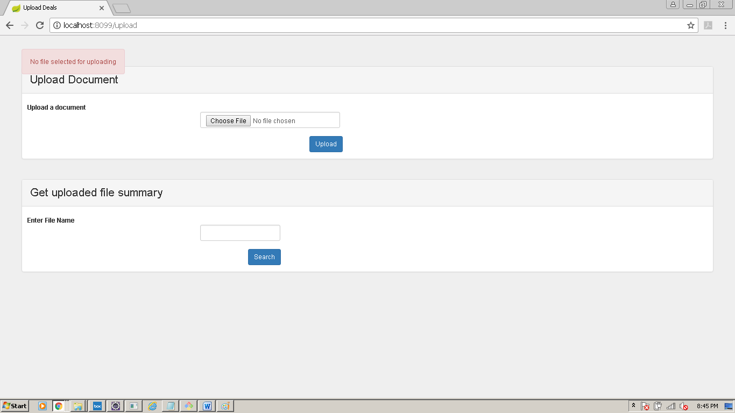

1. File Already Uploaded

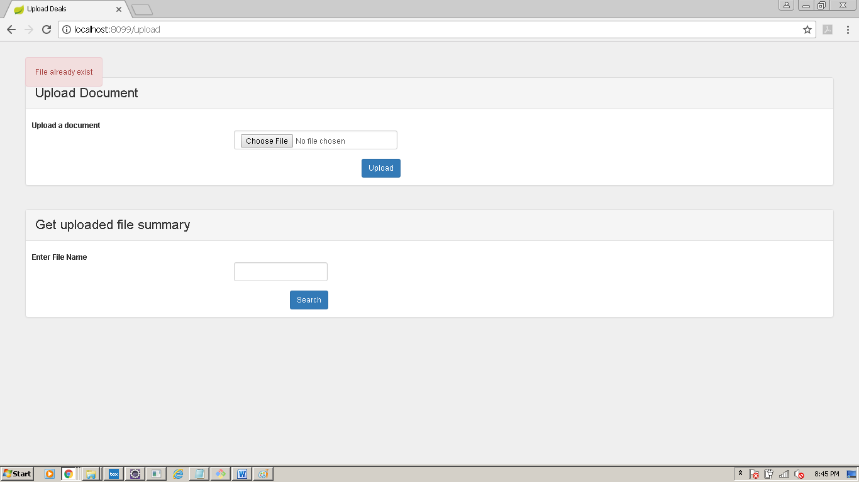

1. No File name entered (Summary)

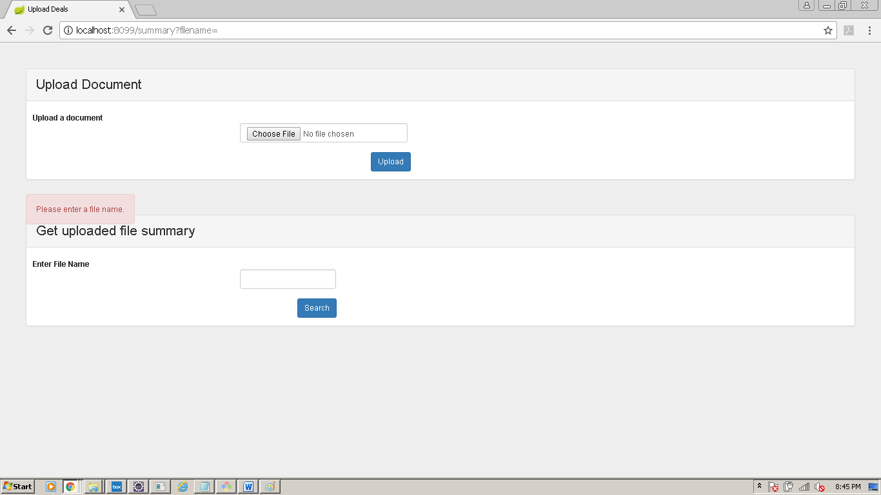

File uploaded

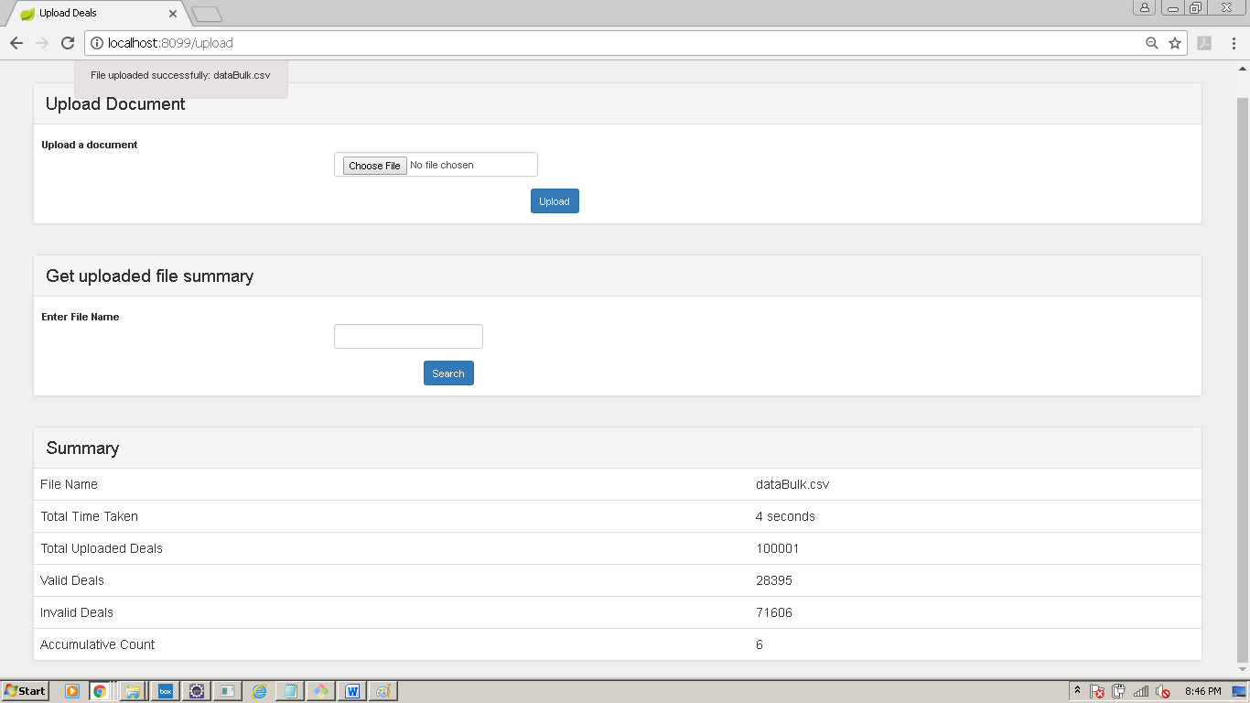

Search uploaded file Summary:

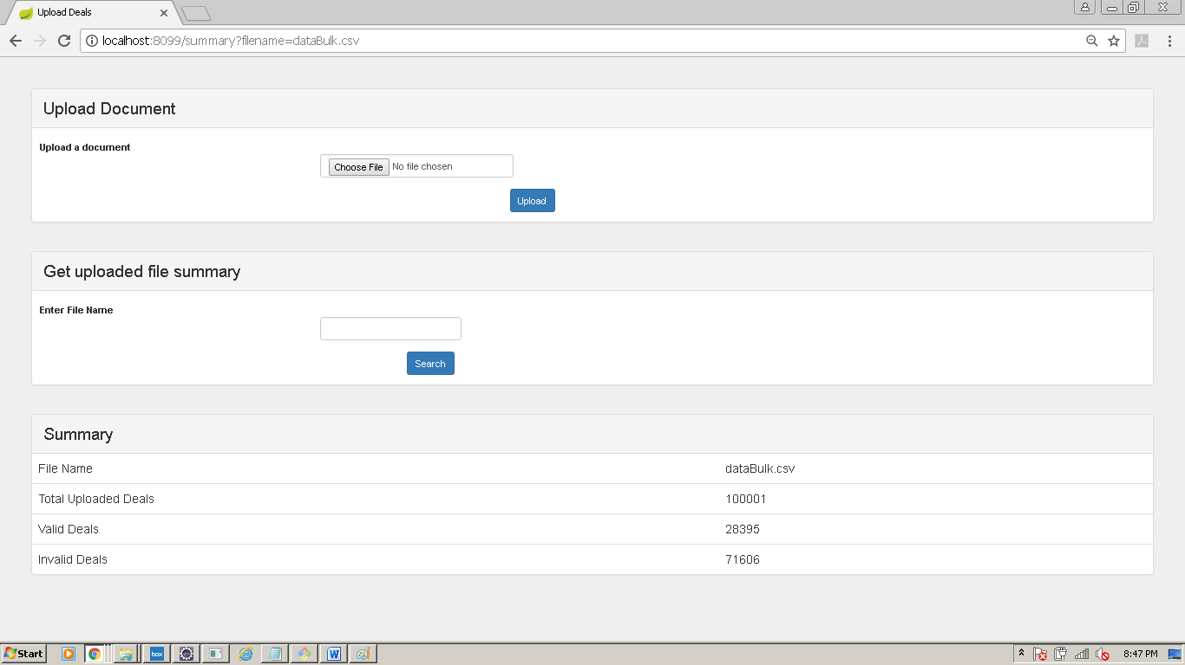

Junit Code Coverage:

